

American International University-Bangladesh (AIUB)  
Department of Computer Science  
Faculty of Science &Technology (FST)  
Spring 23-24

Section: B  
Software Quality Assurance and Testing

DIGITAL BUS SERVICE SYSTEM

A Report Submitted By

|  |  |  |
| --- | --- | --- |
| SN | Student Name | Student ID |
| 1 | Noshin Farzana | 21-44647-1 |
| 2 | Avijit Saha Anto | 21-44630-1 |
| 3 | Arik Ahmed Zelan | 21-44600-1 |
| 4 | MD. Sanim | 21-44606-1 |

**Checked By Industry Personnel**

Name:

Designation:

Company:

Sign:

Date:

Software Test Plan

for

DIGITAL BUS SERVICE SYSTEM

Version 1.0 approved

Prepared by Noshin Farzana, Avijit Saha Anto, Arik Ahmed Zelan, MD.Sanim

American International University-Bangladesh (AIUB)

23 April 2024

Table of Contents

Revision History 3

1. TEST PLAN IDENTIFIER:RS-MTP01.3 4

2. REFERENCES 4

3. INTRODUCTION 4

3.1 Background to the Problem 4

3.2 Solution to the Problem 5

3.3 Project Stakeholders 6

4. REQUEIREMNT SPECIFICATION 7

4.1 System Features 7

4.2 System Quality Attributes 15

4.3 Scope Representation 16

4.4 UML Diagram 17

4.5 User Story 21

4.6 System Interface 24

4.7 Project Requirements 36

5. FEATURES NOT TO BE TESTED 38

6. TESTING APPROACH 39

6.1 Testing Levels 39

6.2 Test Tools 41

6.3 Meetings 41

7. TEST CASES/TEST ITEMS 42

9. TEST DELIVERABLES 54

10. STAFFING AND TRAINING NEEDS 54

11. RESPONSIBILITIES 55

12. TESTING SCHEDULE 56

13. PLANNING RISKS AND CONTINGENCIES 56

14. APROVALS 57

15. PROJECT CLIENT ACCEPTANCE & SIGN-OFF FORM 58

# Revision History

|  |  |  |  |
| --- | --- | --- | --- |
| **Revision** | **Date** | **Updated by** | **Update Comments** |
| 0.1 | 23-04-2024 | Noshin Farzana | First Draft |
| 0.2 | 01-05-2024 | Avijit Saha Anto | Updated Requirement |
| 0.3 | 07-05-2024 | Arik Ahmed Zelan | Updated Test Cases |
| 0.4 | 12-05-2024 | MD. Sanim | Final Revision |

# TEST PLAN IDENTIFIER:RS-MTP01.3

# REFERENCES

* Draw.io (<https://app.diagrams.net/>)
* Clickup (<https://clickup.com/>)
* Microsoft Project

# INTRODUCTION

## 3.1 Background to the Problem

* The technical scope associated with the development and implementation of this **Digital Bus Service System** project will allow passengers to check-in and check-out of their bus rides using a smart card or mobile device. With the help of this project, we can introduce the concept of online-based digital bus service to our audience and encourage them to put their faith in such applications. This system will use GPS technology to track the location of buses in real time and provide estimated arrival and departure times to the passengers. Passengers have access to information through an app, such as current seat capacity and total passenger count of the buses. Scanner machines will be installed on buses to allow passengers to check-in and check-out of their buses. There will be two scanners in the bus. One scanner will be attached at the entrance of the bus where passengers will scan their card to get onto the bus. Another scanner will be attached at the exit door of the bus. The GPS tracker will be installed in the scanner device. Passengers must scan to check-in and check-out from the bus. If and only if a passenger scans the card, he will get access to the bus. Otherwise, the gate of the bus will remain closed. Also, by using GPS technology the system will calculate fares based on the distance travelled and allow passengers to pay using their smart card or mobile devices. For check-out a passenger needs to scan the card so that the fare can be deducted from the card. The exit door will open automatically once the payment is complete. When necessary, a passenger can recharge their card using mobile banking. In case of emergency, when the card balance has run out one can take loan by using the app. In that case, a temporary QR code will be generated in the app and by scanning the code a passenger can check out. The loan amount will be deducted after the next recharge. This allows individuals to provide information such as name, password, gender, age, occupation, and other necessary details for the registration of smart card and getting access to the app. After registration, a smart card will be provided to each person. Students must show their student ID, NID, or birth certificate and other necessary documents during registration to be eligible for the half-pass and the student pass will expire after a certain period of time. We do not need any helpers or ticket checkers on the buses. So, the journey will become more comfortable because it is completely contactless and there is no interaction with ticket checkers.
* In our traditional bus service system, the proper fare is not taken according to the destination as no GPS system is used for calculating the exact distance. As a result, it creates chaos between the passengers and helpers. The feature of scanning the card at the entrance and exit to open the gate of the buses was not available in the previous system. So, there can be a tendency to check-out without paying the fare. It also takes extra time to pick up and drop off passengers. Some of the passengers take advantage of half-pass using expired student id cards as it is very time consuming for the helpers to check the validity of id. This project will help to overcome all the problems concerning these situations.

## 3.2 Solution to the Problem

* **Project objective:** The main objective of **Digital Bus Service System** is to introduce a smart card-based system for check-in and check-out from buses. Keeping our objective in mind, we want to create an online application that can be used worldwide. Also, as this concept is not so familiar in our country, we want people to use and trust our system.
* **The problem, solution, necessity of using this application:** There is no digital bus service application in our country because it is not widely used here. But the thing is the traditional way of bus service system is actually a mess considering different situations. Sometimes passengers get harassed, the exact fare is not taken, and many more unwanted situations can happen. Since our world is getting modernized and almost everything is now online based so we thought of developing a system which people can rely on. A huge part of our population don’t trust online based platforms. Also, in our **Digital Bus Service System** we have implemented some new features which were missing in the previous system. So, our target is to make an online application for bus service which is strongly secured, requires verification of the users, safe and user friendly.
* **The target group of users:** There will be two types of users of the system. The admins and the passengers. Passengers who are having issues with the traditional bus service system can easily register with our system. They can see the information of the bus location along with the departure time. It will save their time as well. Admins will maintain the data and activity of the passengers and if they find any suspicious things going on they can take legal actions like blocking the card of the passengers.
* The existing software solutions that are available to solve the problem are Shohoz (https://www.shohoz.com), bdtickets (https://bdtickets.com), Jatri (https://www.jatri.co) etc. But these systems are used for long distance journey and lack real-time map for fare calculation.

## 3.3 Project Stakeholders

* **End Users:**
  + Passengers who utilize the Digital Bus Service System.
  + Administrators who manage the system and monitor bus operations.
* **Development Team:**
  + Software developers responsible for building and maintaining the system.
  + User interface designers who create interfaces for the mobile app and scanner device.
  + Quality assurance testers who ensure the system functions correctly and meets user requirements.
* **Management Team:**
  + Project managers who supervise the planning, execution, and delivery of the system.
  + HR team responsible for hiring and training human resources required for the project.
  + Budget management team responsible for allocating financial resources.
* **Bus Operators:**
  + Bus operators who manage and operate the buses equipped with the scanner devices.
  + Operations managers who coordinate bus schedules and ensure smooth operations.
* **Technology Partners:**
  + Providers of GPS technology for tracking bus locations in real-time.
  + Payment gateway providers for secure online transactions for card recharge and loan processing.
* **Regulatory Authorities:**
  + Transportation regulatory authorities responsible for overseeing compliance with regulations and standards related to public transportation services.
* **Customer Support Team:**
  + Customer support representatives responsible for assisting users with any issues or inquiries related to the Digital Bus Service System.

# REQUEIREMNT SPECIFICATION

## System Features

* **Common Features**
* **System Feature: Login**

**Functional Requirements:**

* The login page has two options, login and register. It will allow users to login to the system with their given username and password.
* For login to the system database records will be compared with the username and password.
* If the login is successful, the homepage will be shown.
* The system will randomly generate a verification code and send it to the user's email address to try again if the entered username and password are incorrect.
* If a user attempts to login more than three times, the system will display "Forgot Password?"
* Anyone who selects the "Forgot Password" option will see a page where they must enter their mailing address. The user's mailbox will receive a verification code.
* The user will be able to change the password once they have entered the verification code. The user will then be automatically logged in and the home page will appear.
* If the user is new, they will click for register option, and it will take user to the register page.

**Priority Level:** High  
**Precondition:** User have valid user id and password

* **System Feature: Registration**

**Functional Requirements:**

* Users must register to log in to the system.
* In this registration process the user must provide country code, mobile number & email address.
  + Basic information form will be filled by user.
* In this form the user needs to provide his/her name.
* Users should set a password for further login.
* Also, they have to provide date of birth, gender, occupation description, NID number as well as picture of NID, picture of birth certificate and student id (optional).
* User must include his/her photo.
* After giving all the information, the user needs to click the submit button.
* User will submit the code which has sent via email or phone number.
* Admin will verify all the information.
  + User has to wait for the confirmation of admin.
  + After getting confirmation from admin, the user will be successfully registered to the system.

**Priority Level:** High

**Precondition:** User is not registered in the system

* **System Feature: Logout**

**Functional Requirements:**

* The system shall provide a logout option for users to terminate their current session.
* Upon logout, the system shall clear any session data and return the user to the login screen.

**Priority Level:** High

**Precondition:** User is logged into the system

* **System Feature: Home page**

**Functional Requirements:**

* Menu bar
* Home
* Passengers can search for multiple things by using the app.
* They can search for bus location.
* They can check the departure time.
* They can search the availability of the seats.
* When necessary, a passenger can recharge their card using mobile banking.
* In case of emergency, when the card balance has run out one can take loan by using the app. In that case, a temporary QR code will be generated in the app and by scanning the code a passenger can check out. The loan amount will be deducted after the next recharge.
* Passengers can report if they will face any kind of problem regarding the system.
* For any query, they can call to the help center.
* Passengers can check the privacy policy to know about the security of the system.
* Passengers can logout from the app whenever they want.

**Priority Level:** High

**Precondition:** User is logged into the system

* **Admin**
* **System Feature: Confirm Registration**

**Functional Requirements:**

* The system shall allow administrators to confirm user registrations.
* Upon confirmation, the system shall activate the user's account for login.
* If necessary, administrators may review registration details before confirmation.

**Priority Level:** High

**Precondition:** User has submitted registration information

* **System Feature: Monitor Passengers' Activities through App**

**Functional Requirements:**

* The system shall provide administrators with a dashboard to monitor passengers' activities.
* Administrators can view check-in/check-out records, card recharge history, and any flagged activities.

**Priority Level:** High

**Precondition:** Admin is logged into the system

* **System Feature: Monitor Bus Location Using GPS**

**Functional Requirements:**

* The system shall integrate GPS tracking to monitor the real-time location of buses.
* Administrators can access a map interface displaying the current location of each bus.

**Priority Level:** High

**Precondition:** Admin is logged into the system

* **System Feature: Block Card and User from System**

**Functional Requirements:**

* The system shall allow administrators to block specific user accounts and associated smart cards.
* Upon blocking, the system shall deny access to the blocked user and deactivate their smart card for further usage.

**Priority Level:** High

**Precondition:** Admin is logged into the system

* **Passenger**
* **System Feature: Scan Smart Card for Check-in and Check-out**

**Functional Requirements:**

* The system shall integrate with smart card scanning devices to allow users to check-in and check-out of buses.
* Users can scan their smart card to record their journey.

**Priority Level:** High

**Precondition:** User is present at the bus stop with the smart card

* **System Feature: Card Recharge**

**Functional Requirements:**

* The system shall provide a recharge option for users to add credit to their smart cards.
* Users can specify the amount to recharge and complete the transaction securely.
* Upon successful recharge, the system shall update the user's smart card balance.

**Priority Level:** High

**Precondition:** User has a valid payment method and wishes to recharge their smart card

* **System Feature: Take Loan (Emergency Situations)**

**Functional Requirements:**

* The system shall allow users to request a loan in emergency situations.
* Users can specify the loan amount and reason for the request.
* The system shall deduct the loan amount from the user's next recharge.

**Priority Level:** Medium

**Precondition:** User encounters an emergency situation and requires financial assistance

* **System Feature: Use Student Half-pass without Any Hassle**

**Functional Requirements:**

* The system shall automatically apply student half-pass benefits for eligible users.
* Eligibility criteria for student half-pass shall be defined and verified during registration.
* Users shall not need to manually activate the student half-pass feature.

**Priority Level:** Medium

**Precondition:** User is registered as a student and meets eligibility criteria

* **System Feature: See Current Location of Bus**

**Functional Requirements:**

* The system shall display the real-time location of buses on a map interface.
* Users can view the location of nearby buses relative to their current position.

**Priority Level:** High

**Precondition:** User is logged into the system and has access to GPS-enabled features

* **System Feature: Check Departure Time**

**Functional Requirements:**

* The system shall provide information on scheduled departure times for buses.
* Users can check departure times for specific bus routes and plan their journeys accordingly.

**Priority Level:** High

**Precondition:** User is logged into the system and selects a desired bus route

* **System Feature: Check Availability of Seats**

**Functional Requirements:**

* The system shall display the availability of seats on upcoming bus journeys.
* Users can view the number of available seats in real-time and make informed decisions about boarding.

**Priority Level:** High

**Precondition:** User is logged into the system and selects a desired bus journey

* **Scanner Device**
* **System Feature: Save User Information**

**Functional Requirements:**

* The scanner device shall have the capability to save user information retrieved from the smart card.
* User information such as ID, balance, and eligibility status shall be stored securely in the device's memory.
* Stored user information shall be accessible for transaction processing and record-keeping purposes.

**Priority Level:** High

**Precondition:** Scanner device is powered on and operational

* **System Feature: Scan Smart Card**

**Functional Requirements:**

* The scanner device shall be equipped with hardware and software to scan smart cards.
* Upon user presentation of a smart card, the device shall read and validate card data.
* Scanned card data shall include user ID, balance, and any relevant transaction history.

**Priority Level:** High

**Precondition:** Smart card is presented to the scanner device for processing

* **System Feature: Deduct Fare Using GPS**

**Functional Requirements:**

* The scanner device shall utilize GPS technology to determine the distance traveled by the user.
* Based on the distance traveled, the device shall calculate the fare according to predefined fare rules.
* The calculated fare shall be deducted from the user's smart card balance.

**Priority Level:** High

**Precondition:** User has checked in and boarded a bus equipped with the scanner device

* **System Feature: Deduct Loan Amount After Next Recharge**

**Functional Requirements:**

* The scanner device shall keep track of users who have taken a loan.
* Upon the user's next recharge transaction, the device shall deduct the loan amount from the recharge value.
* The deducted loan amount shall be recorded and updated in the user's transaction history.

**Priority Level:** High

**Precondition:** User has successfully recharged their smart card after taking a loan

* **App**
* **System Feature: Save All User Information**

**Functional Requirements:**

* The app shall securely store all user information collected during registration and subsequent interactions.
* User information including but not limited to username, password, contact details, smart card details, and transaction history shall be saved.
* Stored user information shall be encrypted to ensure data security and privacy.

**Priority Level:** High

**Precondition:** App is installed and running on a compatible device

* **System Feature: Provide User Guide**

**Functional Requirements:**

* The app shall include a user guide accessible from the main menu.
* The user guide shall provide detailed instructions on how to use various features of the app.
* The user guide shall cover topics such as registration, login, card recharge, loan requests, and troubleshooting tips.

**Priority Level:** Medium

**Precondition:** User accesses the app and requires assistance with its functionality

* **System Feature: Provide Help Center Contact Information**

**Functional Requirements:**

* The app shall display contact information for the help center or customer support team.
* Contact information shall include phone numbers, email addresses, and operating hours of the help center.
* Users shall be able to access the help center contact information easily from within the app.

**Priority Level:** Medium

**Precondition:** User encounters an issue or requires assistance while using the app

* **System Feature: Card Recharge**

**Functional Requirements:**

* The app shall provide a convenient interface for users to recharge their smart cards.
* Users shall be able to specify the recharge amount and select a preferred payment method.
* Upon successful transaction, the app shall update the user's smart card balance accordingly.

**Priority Level:** High

**Precondition:** User wishes to add credit to their smart card for transportation services

* **System Feature: Give Loans in Emergency Situations and Generate Temporary QR Code**

**Functional Requirements:**

* The app shall include a feature to request emergency loans in critical situations.
* Users can initiate a loan request specifying the required amount and reason for the emergency.
* Upon approval, the app shall generate a temporary QR code representing the loan amount.
* The temporary QR code shall be scanned by scanning devices for transaction processing.

**Priority Level:** High

**Precondition:** User faces an emergency situation requiring immediate financial assistance

## System Quality Attributes

* **Usability:** The system will be easier to learn and use.
* **Availability:** The system is accessible for all types of users and will be available in peak hours like office hours.
* **Scalability:** The system will be able to handle the load of passengers without decreasing the quality.
* **Performance:** The system returns the search results within 1 second.
* **Reliability:** The system will run without a failure for a given period under predefined conditions.
* **Security:** The system maintains the privacy of user information.
* **Interoperability:** The System will be able to exchange data in different module of the system.
* **Portability:** The system can be used from any platform or any devices.

## Scope Representation

**Feature Tree**

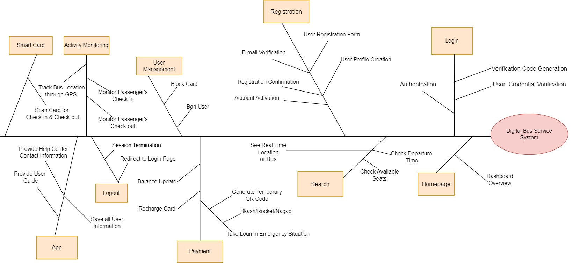

## UML Diagram

**Use Case Diagram**

**Class Diagram**

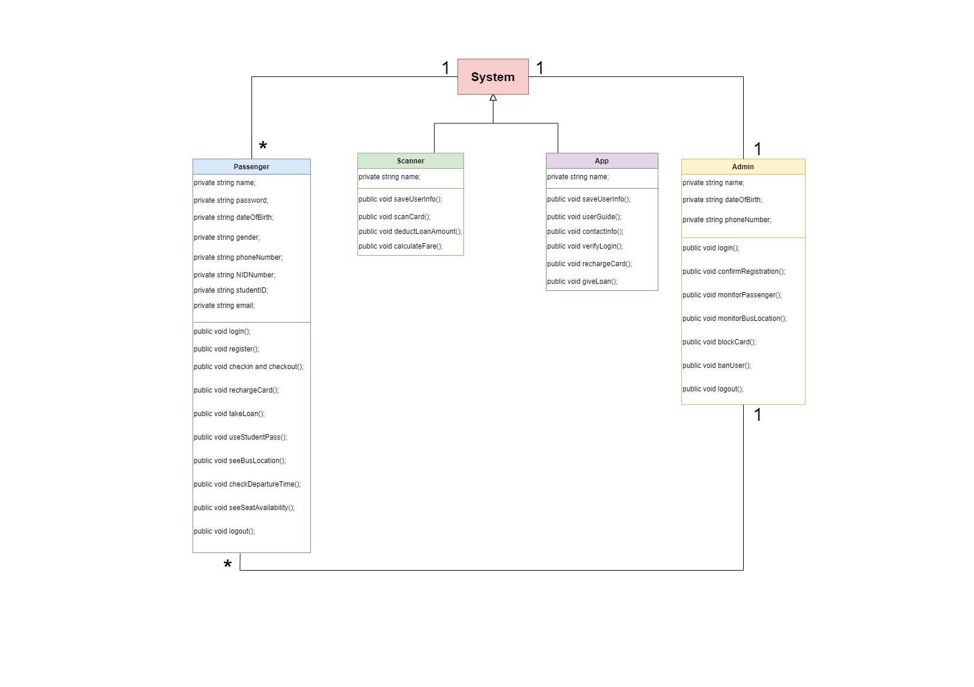

**Activity Diagram**

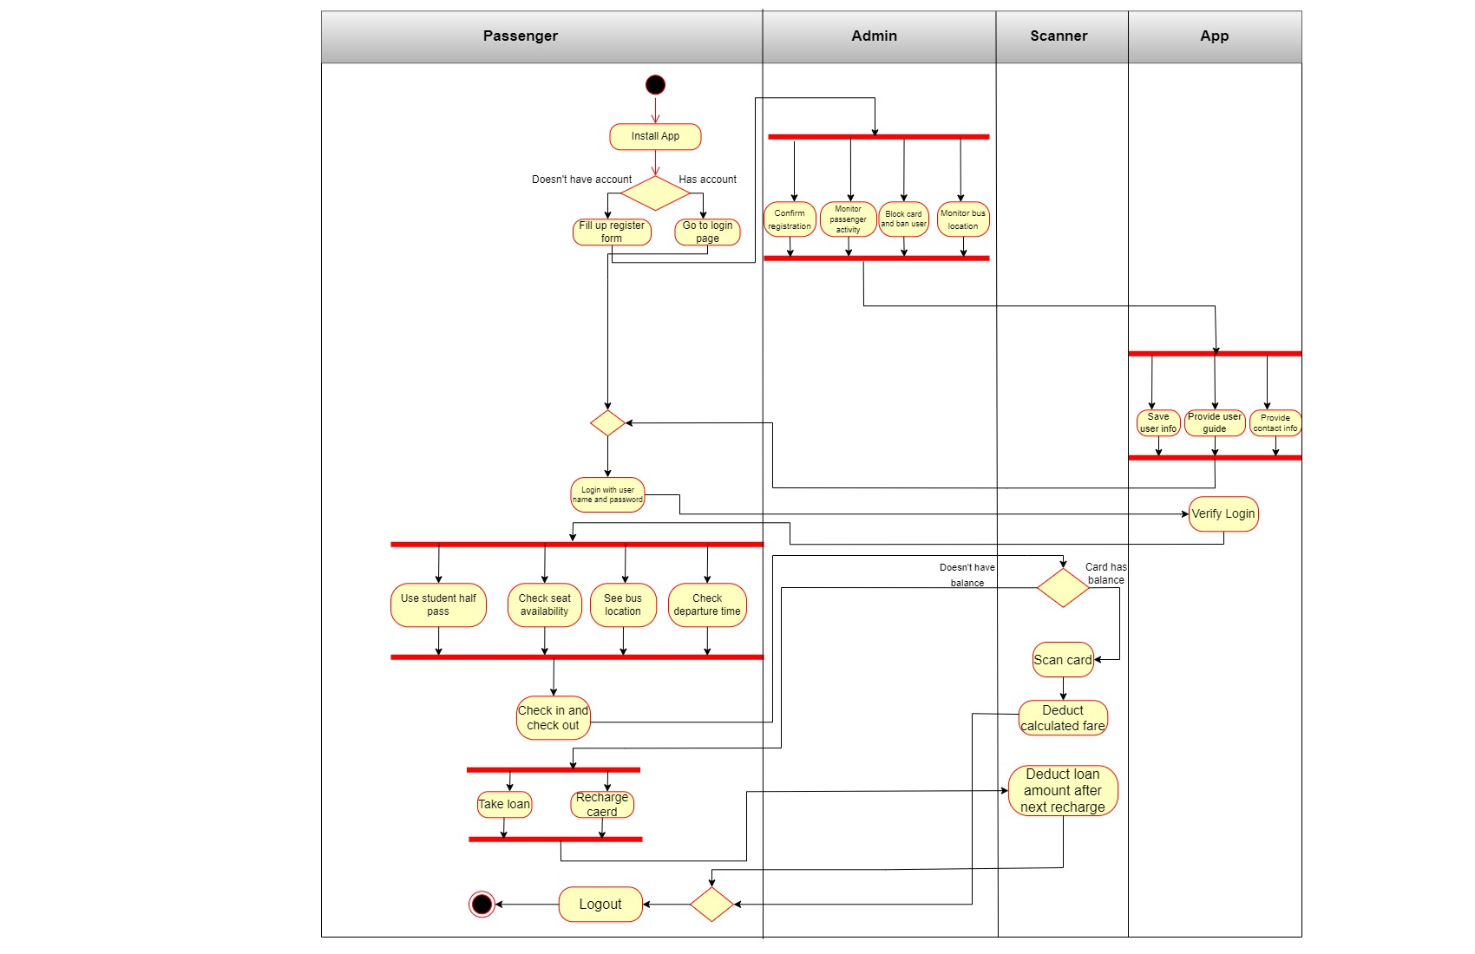

**Sequence Diagram**

## User Story

* **Admin**

| **User Story ID** | **User Story** | **Acceptance Criteria** |
| --- | --- | --- |
| US001 | As an Admin, I want to efficiently manage user registrations by confirming new registrations submitted to the system. | 1. Access to a user-friendly interface for reviewing new registration submissions.  2. Ability to view registration details including user information and submitted documents.  3. Option to approve or reject registration submissions.  4. Upon approval, the user's account is activated for login. |
| US002 | As an Admin, I want to monitor passengers' activities through the app to ensure system security. | 1. Access to a dashboard displaying passenger activities such as check-ins, check-outs, and card recharges.  2. Ability to filter and search for specific passenger activities.  3. Real-time updates on passenger activities. |
| US003 | As an Admin, I want to track the real-time location of buses using GPS to optimize route planning and provide accurate information to passengers. | 1. Access to a map interface displaying the current location of all buses.  2. Ability to zoom in/out the map to view bus locations.  3. Real-time updates on bus locations.  4. Option to view bus routes and scheduled stops.  5. Integration with GPS technology to ensure accurate bus tracking. |
| US004 | As an Admin, I want the ability to block specific user accounts and associated smart cards from the system in case of misuse or security concerns. | 1. Access to a user management interface for blocking user accounts and smart cards.  2. Ability to search for specific users or smart cards by ID or name.  3. Blocked users are denied access to the system and their smart cards are deactivated.  4. Option to unblock previously blocked users if necessary. |

* **Passenger**

| **User Story ID** | **User Story** | **Acceptance Criteria** |
| --- | --- | --- |
| US001 | As a Passenger, I want a user-friendly login process to access the system efficiently. | 1. Access to a login page with options for login and registration.  2. Ability to login with username and password.  3. Option to register for new users.  4. Secure verification code generation in case of login failures. |
| US002 | As a Passenger, I want a registration process to create my account in the system. | 1. Access to a registration form with fields for necessary information.  2. Submission of basic information including name, password, contact details, and identification documents.  3. Verification code sent to email or phone for confirmation.  4. Confirmation of registration upon admin approval. |
| US003 | As a Passenger, I want the ability to log out of the system securely. | 1. Access to a logout option within the app interface.  2. Clearing of session data to ensure privacy and security. |
| US004 | As a Passenger, I want a user-friendly home page with navigation options. | 1. Access to a home page with a menu bar for easy navigation.  2. Options to search for bus locations, check departure times, and view seat availability.  3. Access to card recharge and loan options.  4. Ability to report system problems and contact the help center.  5. Access to privacy policy and logout option. |
| US005 | As a Passenger, I want the system to provide real-time updates on bus locations. | 1. Access to a map interface displaying the current location of buses.  2. Ability to view nearby buses relative to current position. |
| US006 | As a Passenger, I want to check the departure times of buses for planning my journey. | 1. Access to departure time information for specific bus routes.  2. Ability to search for departure times based on route and time. |
| US007 | As a Passenger, I want to check the availability of seats on upcoming bus journeys. | 1. Access to seat availability information for upcoming bus journeys.  2. Real-time updates on available seats. |
| US008 | As a Passenger, I want to scan smart cards to check-in and check-out for bus journeys. | 1. Capability to scan smart cards for check-in and check-out. |
| US009 | As a Passenger, I want the ability to recharge my smart card for transportation services. | 1. Access to a recharge option within the app interface.  2. Specification of recharge amount and payment method.  3. Successful transaction completion and update of smart card balance. |
| US010 | As a Passenger, I want the option to request a loan in emergency situations. | 1. Access to a loan request feature within the app interface.  2. Specification of loan amount and reason for request.  3. Generation of temporary QR code representing the loan amount upon approval.  4. Deduction of loan amount from next recharge. |
| US011 | As a Passenger, I want the system to apply student half-pass benefits automatically. | 1. Automatic application of student half-pass benefits for eligible users.  2. Verification of student status during registration. |
| US012 | As a Passenger, I want the app to provide a comprehensive user guide for easy navigation and feature understanding. | 1. Access to a user guide within the app interface.  2. Detailed instructions on app features and functionalities. |
| US013 | As a Passenger, I want the app to display help center contact information for assistance with any issues. | 1. Display of help center contact details including phone numbers and email addresses.  2. Accessibility of contact information from within the app. |

## System Interface

First the users will see this Login page.

Then, if the user already has an account, he or she needs to login with their username and password. If not, then by clicking the Register button the users can create their account. Also, if any user forgot the password, he can recover it through “Forgot password?” button.

Verification page.

Basic information page.

After submitting, Admin will verify the information and confirm registration. Then this box will be shown.

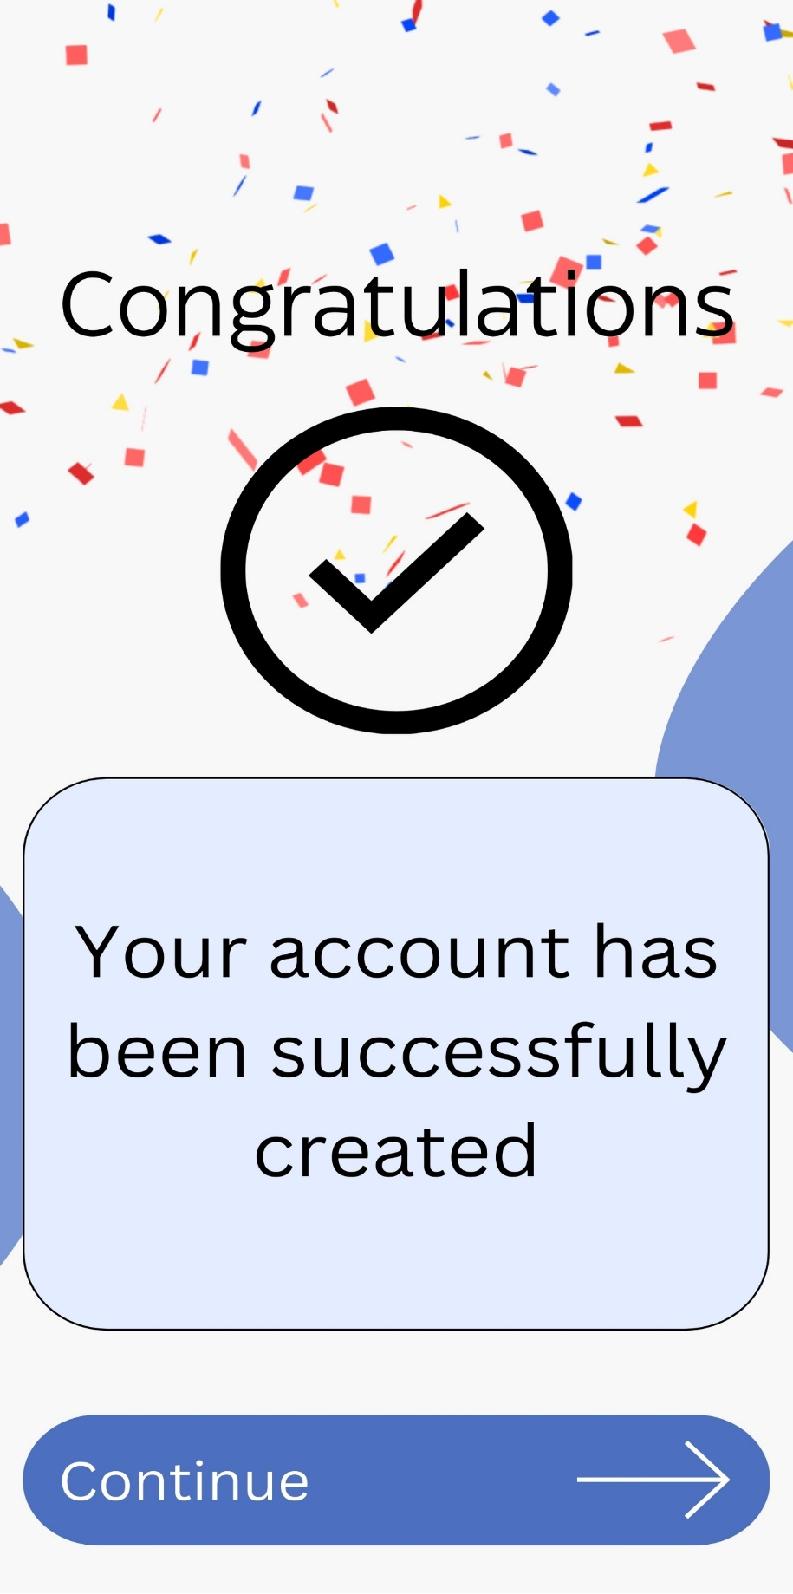

This is the home page view for the Passengers.

Search page.

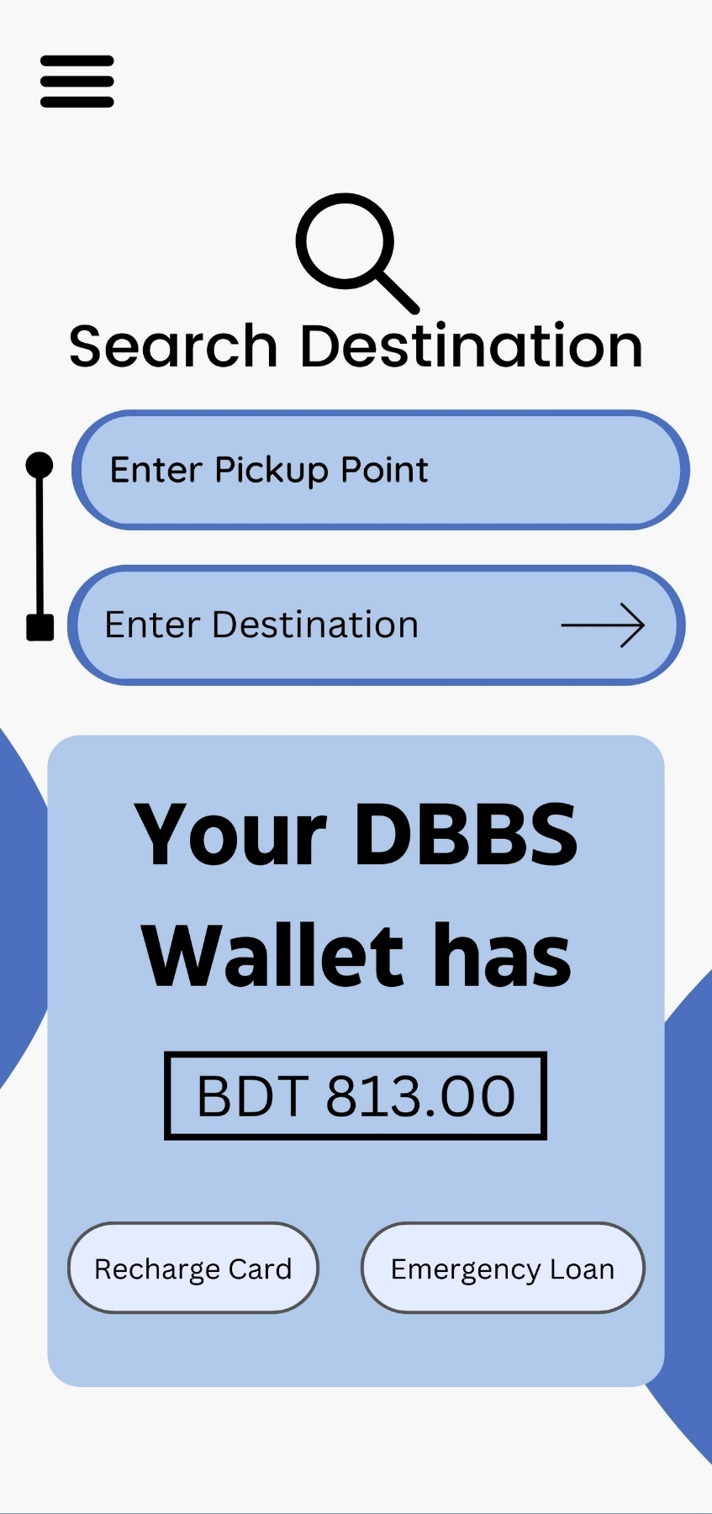

Recharge page.

Passengers can take a loan in emergency situations.

If Passengers face any kind of problem, they can report.

After verifying the information, Admin can confirm the Passenger’s registration.

Admin can see the passenger details and if he notices any kind of suspicious activity, he can block the card of the Passenger.

## Project Requirements

* **Time Estimation**

An algorithmic software cost estimating methodology is the Constructive Cost Model (COCOMO). We will be using an organic software project type. It is a software project that must be worked on in a hardware-dependent environment.

**Constructive Cost Model**

We are assuming the SLOC (Source Lines of Code) that we require here after analyzing all the components. SLOC = 45,000

Now we need to figure out the effort, development time, and required number of people.

Our software project type is organic. So, the values of the

Coefficient<Effort Factor> =2.4

P = project complexity = 1.05

T = SLOC-dependent coefficient = 0.38

Now,

Effort, PM = Coefficient*(SLOC/1000) P

= 2.4*(45000/1000)1.05

= 130.64

= 131

Development Time, DM = 2.50*(PM)T

= 2.50*(131)0.38

= 15.94

= 16 [In months]

Required Number of People, ST = PM/DM

= 131/16

= 8.19

= 9

**Schedule Breakdown**

|  |  |
| --- | --- |
| **Task Name** | **Duration** |
| Requirement Gathering and Analysis | 5 weeks |
| Documentation | 2 weeks |
| Design and Architecture | 3 weeks |
| Development | 9 months |
| Test Plan | 2 weeks |
| Unit Testing | 5 weeks |
| Integration Testing | 3 weeks |
| System Testing | 2 weeks |
| Security Testing | 2 weeks |
| System Testing Bug Report | 1 week |
| Acceptance Testing | 2 weeks |
| Acceptance Test Bug Report | 1 week |
| Project Deployment | 1 week |
| Support and Maintenance | On going |
| Total | 16 months |

**So, Total Development time 16 months.**

To develop the software:

* Developer team of 4 engineers.
* Software Quality assurance team of 2 engineers.
* 1 Business Analyst
* 2 UI/UX Designer
* **Budget Estimation**

|  |  |
| --- | --- |
| **Resource Name** | **Cost** |
| Project Management Team | 50 k |
| HR Team | 50 k |
| Software Designer Team | 80 k |
| Software Development Team | 2 lacs |
| Quality Assurance Team | 1 lac |
| System Testing Team | 30 k |
| Computers | 50 k |
| Server | 40 k |
| Internet | 10 k |
| Software Tools and Software Licenses | 80 k |
| Office Supplies | 10 k |
| Maintenance | 30 k |
| Miscellaneous | 20 k |
| Total | 7 lacs 50 thousand |

**So, Total Budget 7 lacs 50 thousand BDT.**

* **Operating Environment**
* **Technology Infrastructure:**
* **Server Infrastructure:** The system relies on robust servers to host the application, databases, and handle data processing.
* **Database Management System (DBMS):** The choice of DBMS affects data storage, retrieval, and management. Common systems include MySQL, PostgreSQL, or NoSQL databases.
* **Programming Languages and Frameworks:** The system may be built using languages like Python, Java, or PHP, and frameworks such as Django or Laravel.
* **Network Infrastructure:**
* **Internet Connectivity:** Users access the system via the internet, making a stable and secure connection.
* **Bandwidth:** Sufficient bandwidth will be provided for smooth data transfer, especially when dealing with multimedia content.
* **Client Devices:**
* **Web Browsers:** Compatibility with major web browsers like Chrome, Firefox, Safari, and Edge will be provided.
* **Mobile Devices:** As many users may access the system via mobile devices, responsiveness and mobile optimization will be provided.

# FEATURES NOT TO BE TESTED

* **Block browsing the website from different devices:**

If a user tries to browse the website from different devices the system will block it and make logout all the users except the last login device. This feature will not be tested in this test plan.

* **Compliance with Specific Regional Regulations:**

Testing compliance with specific regional regulations, such as transportation laws or regulations, will not be explicitly tested in the initial phase but should be ensured through legal review and compliance checks.

# TESTING APPROACH

## Testing Levels

* **Unit Testing:**

**Responsibility:** Developers  
**Approver:** Development Team Leader

**Focus:** Testing individual modules (units) of the system

**Deliverables:**

* Test case list for each unit/module.
* Sample output demonstrating expected behavior.
* Data printouts for verification.

**Process:**

* Developers will perform unit testing on the following modules such as-
* **Login Module:** Test login functionality, including verification code generation, email sending, and forgot password functionality.
* **Logout Module:** Test logout functionality.
* **Registration Module:** Test process for user registration with email, password, basic information and registration confirmation process.
* **Search Module:** Test search functionalities like see real-time location of bus, departure time, available seats etc.
* **Payment Module:** Test card recharge and card blocking process including payment, balance update, loan request and temporary QR code generation for check-in or check-out.
* Test results along with test case lists, sample outputs, and defect information will be provided to the Development Team Leader.
* The Development Team Leader will review and approve the unit testing results before passing them to the test manager.
* **System/Integration Testing:**

**Responsibility:** Test Manager, Development Team Leader, Developers  
**Approver:** Test Manager

**Focus:** Testing integrated modules of the system as a whole

**Deliverables:**

* System/Integration test plan.
* Test cases covering end-to-end scenarios.
* Test results documenting any defects found.

**Process:**

* Testing begins after all critical defects from unit testing have been resolved and integrating all the modules.
* After integrating the system with the hardware (scanner device), testing all the functionalities.
* Test results are documented and shared with the testing team for further action.
* **Acceptance Testing:**

**Responsibility:** End Users   
**Approver:** Client or End Users

**Focus:** Validating the system against user requirements in a real-world environment

**Deliverables:**

* Acceptance test plan.
* Feedback from end users.
* Comparison of system performance with the existing manual process.

**Process:**

* **End-to-End Functionality Testing:** Test the entire user journey from registration to logout and test various scenarios.
* **User Experience Testing:** Evaluate the usability of the system and gather feedback on ease of use.
* **Performance Testing:** Test system performance, including response times for different features and peak load handling.
* **Security Testing:** Verify security measures implemented to protect user information and test for vulnerabilities.

By covering these testing categories, we ensure that all features of the **Digital Bus Service System** are thoroughly tested and meet quality standards and user requirements.

## Test Tools

As the Digital Bus Service System is a web-based software, only an automatic testing tool, Selenium IDE will be used for testing user interfaces, including website functionality, regression testing, and browser compatibility testing. Using this software, the software developers and QA team will perform unit testing and the Software development leader and QA leader will perform integration testing.

## Meetings

In the two-three months software test plan, the team will meet weekly to evaluate progress, analyze test results and plan for the upcoming week. In each month the test team leader will arrange meetings between the test teams to ensure all testing is being done properly. Additionally, a daily 15 to 20 minutes meeting will be conducted to discuss about the daily testing progress and which testing will be conducted next will also be discussed. Emergency meetings can be called in case of urgent issues. At the end of the testing phase, a test closure meeting will be held with all project members. This meeting will serve to review the overall testing process, discuss any outstanding issues or concerns, and finalize the testing documentation and reports.

# TEST CASES/TEST ITEMS

|  |  |  |  |  |  |
| --- | --- | --- | --- | --- | --- |
| Project Name: Digital Bus Service System | | | | Test Designed by: Noshin | |
| Test Case ID: FR_1_1  Test priority (Low, Medium, High): High  Module Name: Login | | | | Test Designed date: 25-04-2024  Test Executed by: Noshin  Test Execution date: 25-04-2024 | |
| Test Title: Verify login with valid username and password | | | |  | |
| Description: Test app login page  Precondition (If any): User must have valid username and password | | | |  | |
| Test Steps | Test Data | Expected Results | Actual Results |  | Status  (Pass/Fail) |
| 1. Go to app 2. Enter username 3. Enter password 4. Click login | Username: Noshin Farzana  Password: 667 | User should login into the application | As expected |  | Pass |
| Post Condition: User is validated with database and successfully login to account. The account session details are logged in the database. | | | | | |

|  |  |  |  |  |  |
| --- | --- | --- | --- | --- | --- |
| Project Name: Digital Bus Service System | | | | Test Designed by: Avi | |
| Test Case ID: FR_1_2  Test priority (Low, Medium, High): High  Module Name: Login | | | | Test Designed date: 25-04-2024  Test Executed by: Avi  Test Execution date: 25-04-2024 | |
| Test Title: Verify login with wrong username and password | | | |  | |
| Description: Test app login page  Precondition (If any): User doesn’t need valid username and password | | | |  | |
| Test Steps | Test Data | Expected Results | Actual Results |  | Status  (Pass/Fail) |
| 1. Go to app 2. Enter username 3. Enter password 4. Click login | Username: Nfe  Password: 123 | User should not login into the application | As expected |  | Pass |
| Post Condition: User is not validated with database and could not login to account. | | | | | |

|  |  |  |  |  |  |
| --- | --- | --- | --- | --- | --- |
| Project Name: Digital Bus Service System | | | | Test Designed by: Avi | |
| Test Case ID: FR_2  Test priority (Low, Medium, High): High  Module Name: Logout | | | | Test Designed date: 25-04-2024  Test Executed by: Avi  Test Execution date: 25-04-2024 | |
| Test Title: Logout from the system | | | |  | |
| Description: Test app logout  Precondition (If any): User must login to the system | | | |  | |
| Test Steps | Test Data | Expected Results | Actual Results |  | Status  (Pass/Fail) |
| 1. Click logout button |  | User should be able to logout anytime from homepage | As expected |  | Pass |
| Post Condition: User is validated with database and successfully logged out from system. | | | | | |

|  |  |  |  |  |  |
| --- | --- | --- | --- | --- | --- |
| Project Name: Digital Bus Service System | | | | Test Designed by: Noshin | |
| Test Case ID: FR_3  Test priority (Low, Medium, High): High  Module Name: Forgot Password | | | | Test Designed date: 25-04-2024  Test Executed by: Noshin  Test Execution date: 25-04-2024 | |
| Test Title: Set new password | | | |  | |
| Description: Test app forgot password  Precondition (If any): User must have valid username, phone number and email | | | |  | |
| Test Steps | Test Data | Expected Results | Actual Results |  | Status  (Pass/Fail) |
| 1. Go to app 2. Click forgot password 3. Enter username 4. Enter phone number 5. Enter email 6. Verify details 7. Set new password | New Password: abcd | User will be able to set new password | As expected |  | Pass |
| Post Condition: User successfully set new password. | | | | | |

|  |  |  |  |  |  |
| --- | --- | --- | --- | --- | --- |
| Project Name: Digital Bus Service System | | | | Test Designed by: Noshin | |
| Test Case ID: FR_4  Test priority (Low, Medium, High): High  Module Name: Registration | | | | Test Designed date: 25-04-2024  Test Executed by: Noshin  Test Execution date: 25-04-2024 | |
| Test Title: Register to the system | | | |  | |
| Description: Test app registration page  Precondition (If any): User must have valid phone number and email | | | |  | |
| Test Steps | Test Data | Expected Results | Actual Results |  | Status  (Pass/Fail) |
| 1. Go to app 2. Click register 3. Enter phone number 4. Enter email 5. Choose country code 6. Enter 6 digit code to verify 7. Fill the basic information form 8. Click submit | Phone: 01752930004  Email: [noshinfarzana681@gmail.com](mailto:noshinfarzana681@gmail.com)  Country code: +880  Verify Code: 146808  Name: Noshin Farzana  Gender: Female  Date of Birth: 30/11/2001  Occupation: Student  Set password: 667  NID number: 1234567890  Picture of NID:  Picture of Birth Certificate:  Passport Photo:  Picture of Student ID: | User should be able to do registration by enter phone number, email, and country code.  User should be able to submit verification code and verify.  User should be able to fill the basic information form. | As expected |  | Pass |
| Post Condition: User is successfully registered to the system. | | | | | |

|  |  |  |  |  |  |
| --- | --- | --- | --- | --- | --- |
| Project Name: Digital Bus Service System | | | | Test Designed by: Noshin | |
| Test Case ID: FR_5  Test priority (Low, Medium, High): High  Module Name: Search | | | | Test Designed date: 25-04-2024  Test Executed by: Noshin  Test Execution date: 25-04-2024 | |
| Test Title: Search options in app | | | |  | |
| Description: Test app search page  Precondition (If any): User must login to the system | | | |  | |
| Test Steps | Test Data | Expected Results | Actual Results |  | Status  (Pass/Fail) |
| 1. Go to app 2. Login 3. Click search 4. Search for current location of bus 5. Search for departure time 6. Search for available seats | See the available seats | User will be able to search | As expected |  | Pass |
| Post Condition: User successfully searched all the options. | | | | | |

|  |  |  |  |  |  |
| --- | --- | --- | --- | --- | --- |
| Project Name: Digital Bus Service System | | | | Test Designed by: Noshin | |
| Test Case ID: FR_6  Test priority (Low, Medium, High): High  Module Name: Recharge Card | | | | Test Designed date: 25-04-2024  Test Executed by: Noshin  Test Execution date: 25-04-2024 | |
| Test Title: Recharge the smart card for check-in and check-out | | | |  | |
| Description: Test app recharge card  Precondition (If any): User must login to system | | | |  | |
| Test Steps | Test Data | Expected Results | Actual Results |  | Status  (Pass/Fail) |
| 1. Go to app 2. Login 3. Click recharge card 4. Select payment method | Payment method: Bkash | User will be able to recharge | As expected |  | Pass |
| Post Condition: User successfully recharged the card. | | | | | |

|  |  |  |  |  |  |
| --- | --- | --- | --- | --- | --- |
| Project Name: Digital Bus Service System | | | | Test Designed by: Noshin | |
| Test Case ID: FR_7  Test priority (Low, Medium, High): High  Module Name: Emergency Loan | | | | Test Designed date: 25-04-2024  Test Executed by: Noshin  Test Execution date: 25-04-2024 | |
| Test Title: Take loan in emergency situations | | | |  | |
| Description: Test app emergency loan  Precondition (If any): User must login to system | | | |  | |
| Test Steps | Test Data | Expected Results | Actual Results |  | Status  (Pass/Fail) |
| 1. Go to app 2. Login 3. Click emergency loan 4. Enter loan amount 5. Confirm | Loan Amount:150 | User will be able to take emergency loan | As expected |  | Pass |
| Post Condition: User successfully took loan from the app. | | | | | |

|  |  |  |  |  |  |
| --- | --- | --- | --- | --- | --- |
| Project Name: Digital Bus Service System | | | | Test Designed by: Noshin | |
| Test Case ID: FR_8  Test priority (Low, Medium, High): Medium  Module Name: Report a Problem | | | | Test Designed date: 25-04-2024  Test Executed by: Noshin  Test Execution date: 25-04-2024 | |
| Test Title: Report any kind of problem | | | |  | |
| Description: Test app report a problem  Precondition (If any): User must login to system | | | |  | |
| Test Steps | Test Data | Expected Results | Actual Results |  | Status  (Pass/Fail) |
| 1. Go to app 2. Login 3. Click report a problem 4. Write problem description 5. Submit | Problem Description: Server is down. | User will be able to report | As expected |  | Pass |
| Post Condition: User successfully submitted the report. | | | | | |

|  |  |  |  |  |  |
| --- | --- | --- | --- | --- | --- |
| Project Name: Digital Bus Service System | | | | Test Designed by: Noshin | |
| Test Case ID: FR_9  Test priority (Low, Medium, High): High  Module Name: Current Balance | | | | Test Designed date: 25-04-2024  Test Executed by: Noshin  Test Execution date: 25-04-2024 | |
| Test Title: See the current balance of card | | | |  | |
| Description: Test app current balance  Precondition (If any): User must login to system | | | |  | |
| Test Steps | Test Data | Expected Results | Actual Results |  | Status  (Pass/Fail) |
| 1. Go to app 2. Login 3. Click current balance | Current Balance: 700 | User will be able to see current balance | As expected |  | Pass |
| Post Condition: Has successfully seen the balance. | | | | | |

|  |  |  |  |  |  |
| --- | --- | --- | --- | --- | --- |
| Project Name: Digital Bus Service System | | | | Test Designed by: Noshin | |
| Test Case ID: FR_10  Test priority (Low, Medium, High): High  Module Name: Pending Request List | | | | Test Designed date: 25-04-2024  Test Executed by: Noshin  Test Execution date: 25-04-2024 | |
| Test Title: Confirm pending request list | | | |  | |
| Description: Test app pending request list  Precondition (If any): Admin must login to system | | | |  | |
| Test Steps | Test Data | Expected Results | Actual Results |  | Status  (Pass/Fail) |
| 1. Go to app 2. Login 3. Click pending request list 4. Select passenger 5. Confirm registration | Select Noshin Farzana | Admin will be able to confirm registration | As expected |  | Pass |
| Post Condition: Admin successfully confirmed passenger request. | | | | | |

|  |  |  |  |  |  |
| --- | --- | --- | --- | --- | --- |
| Project Name: Digital Bus Service System | | | | Test Designed by: Noshin | |
| Test Case ID: FR_11  Test priority (Low, Medium, High): High  Module Name: Passenger Details | | | | Test Designed date: 25-04-2024  Test Executed by: Noshin  Test Execution date: 25-04-2024 | |
| Test Title: See passenger details and ban passenger if needed. | | | |  | |
| Description: Test app passenger details  Precondition (If any): Admin must login to system | | | |  | |
| Test Steps | Test Data | Expected Results | Actual Results |  | Status  (Pass/Fail) |
| 1. Go to app 2. Login 3. Click passenger details 4. Select passenger 5. Ban | Select XYZ | Admin will be able to ban | As expected |  | Pass |
| Post Condition: Admin successfully banned passenger from the system. | | | | | |

1. **ITEM PASS/FAIL CRITERIA**

The test process will be completed once the registered passengers will be able to search for buses to reach their destination and check-in or check-out through scanning smart card successfully. After check-out the fare must be deducted from their smart card as expected.

# TEST DELIVERABLES

* **Requirement Documentation:** All functional and non-functional requirements including user stories, use cases, and acceptance criteria.
* **System Interfaces:** Description of all interfaces the system interacts with, including hardware devices (GPS trackers, smart card scanners) and external systems (payment gateways, database).
* **Unit Test Plans:** Detailed plans outlining the testing approach for individual components (units) of the system, specifying test cases, input data, expected results, and methods for execution.
* **Integration/System Test Plans:** Plans for testing the integration of system components and the overall system functionality, including test scenarios, test data, environment setup, and testing procedures.
* **Security Test Plans:** Plans for testing the security features and vulnerabilities of the system.
* **Acceptance Test Plans:** Plans outlining the criteria and procedures for user acceptance testing (UAT), including test scenarios, acceptance criteria, roles and responsibilities of stakeholders, and methods for feedback collection.
* **Test Logs and Turnover Reports:** Logs documenting all test activities performed during the testing phase, including test execution results, defects found, resolutions, and turnover reports summarizing the overall testing process.
* **Report Mock-ups:** The layout and content of various system reports, including passenger activity reports, bus location reports, fare calculation reports, and system usage statistics.

# STAFFING AND TRAINING NEEDS

* **Project Management Team Formation:**
  + First of all a dedicated project management team will be established as the primary decision-making body for the project.
  + All major decisions, including resource allocation, project goals and budget approvals, will require approval from the project management team.
* **HR Team Formation:**
  + Within the project management team, some members will form the HR team responsible for hiring human resources.
  + The HR team will collaborate with project leads to determine the required resources, such as system interface designers, software development teams, quality assurance teams, and system testing teams.
* **Resource Allocation and Training:**
  + Based on project requirements, the project management team will specify the number and types of resources needed.
  + Each team member will be trained ensuring they are prepared for the development and testing processes.

# RESPONSIBILITIES

|  |  |  |  |  |  |
| --- | --- | --- | --- | --- | --- |
| **Task** | **TM** | **PM** | **Dev Team** | **Test Team** | **Client** |
| Test Cases Documentation | X | X | X | X |  |
| Test Procedures and Rules | X |  | X | X |  |
| Unit Test Documentation & Execution |  |  | X | X |  |
| Integration Test Documentation & Execution | X |  | X | X |  |
| System Test Documentation & Execution |  | X |  | X |  |
| System Design Reviews | X | X | X | X | X |
| Details Design Reviews | X | X | X | X |  |
| Screen & Report Prototype Reviews | X | X |  | X | X |
| Change Control and Regression Testing | X | X | X | X | X |
| Acceptance Test Documentation & Execution | X | X |  | X | X |

# TESTING SCHEDULE

# PLANNING RISKS AND CONTINGENCIES

In this project, if staff leave their job, it'll be tough to quickly replace them. Finding and training new team members takes time and money. As a result, our budget could increase, and the project might get delayed.

| **Risk** | **Probability** | **Impact** |
| --- | --- | --- |
| Staff turnover will be high | 40% | 2 |
| Budget Problem | 60% | 1 |
| Scheduling problem | 40% | 2 |

* 1 = Catastrophic
* 2 = Critical
* 3 = Marginal
* 4 = Negligible

# APROVALS

|  |  |  |
| --- | --- | --- |
| **Name** | **Role** | **Signature** |
| AIUB | Project Sponsor |  |
| Abhijit Bhowmik | QA Lead |  |
| Noshin Farzana | Project Manager |  |
| Avijit Saha Anto | Test Manager |  |
| Arik Ahmed Zelan | Development Team Manager |  |
| MD. Sanim | Business Analyst |  |

**PROJECT CLIENT ACCEPTANCE & SIGN-OFF FORM**

**Digital Bus Service System**

|  |  |
| --- | --- |
| **Project Name:** | **Digital Bus Service System** |
| **This Document is Issued by:** | Noshin Farzana |
| **Date:** | 14 May, 2024 |

I have carefully assessed the specifications and deliverables for the **Digital Bus Service System**. Management certification- Please check the appropriate statement.

The project deliverables are accepted.

The project is accepted pending the issues noted. (below)

The project is not accepted. (for the reasons provided below)

We fully accept the changes as needed improvements and authorize initiation of work to proceed.

Based on our authority and judgment, the continued operation of this system is authorized.

***Noshin 14-05-24***

Project Manager Date

***Avijit******14-05-24***

Test Manager Date

***Zelan******14-05-24***

Development Team Manager Date

***XYZ 14-05-24***

Client Date